Avant-Garde: What is it?

Avant-garde is a form of art that tries to push the limits of what is considered possible by the public by using experimental and radical methods, or methods that are unorthodox with respect to art, religion, culture or society. It first appeared in reference to art in France (where it’s name originates from “advanced guard”), near the first half of the 19th century. It is often credited to Henri de Saint-Simon.

Avant-garde art is said to begin near the 1850s with the art form of realism, created by Gustave Courbet. Some other popular avant-garde movements are those such as cubism, futurism, surrealism, and De Stijl. The term originally was applied to innovative approaches to art within the nineteenth and early twentieth century, however it is still very applicable to forms of radical art today that reflect originality of vision.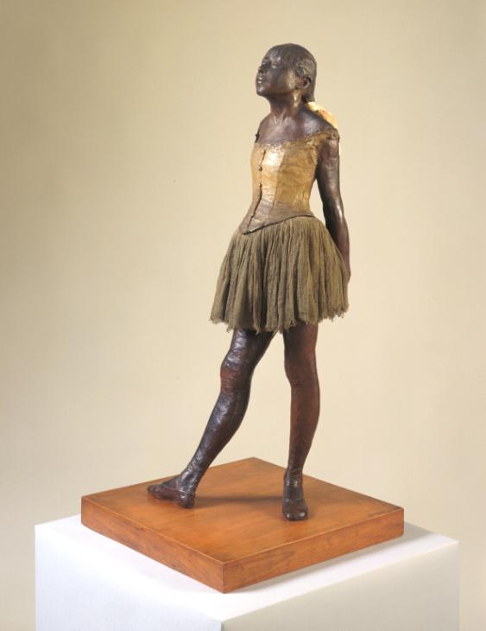

Because of its radical nature, and the fact it challenges ideas that already exist, and processes, avant-garde art pieces and the artists themselves come hand-in-hand with controversy. For example, Edgar Degas’ “Little Dancer Aged Fourteen” (pictured to the left). As innocent as the sculpture looks to us, Degas’ Little Dancer caused an outcry when first released. The figure was named “repulsive” and “a threat to society”.

Avant-garde is the ideology of painters, writers, musicians, and artists from other origins whose ideas, styles, and methods are radical, and turn against the style that the modern society wants them to conform to. Art aside, New York is often called the “international capital of the musical avant-garde”. Avant-garde is designed to be thought provoking, and to make the audience think about what is really happening behind the actual painting, and to think more about the philosophical meaning of these pieces.

There comes a point in art where you can see a clear difference between art that conforms solely to the politically correct meaning of art, to not be controversial, to not be thought provoking, to just be a few colours and lines. To create a piece of avant-garde art means to subvert the stereotypes of the politically correct, to be controversial, to be what modern society doesn’t want you to be. If we all conform to the politically correct, then we all lose a piece of us. We can no longer begin conversations on important topics, we can no longer create these important political conversations that help to change people’s lives. The art form of avant-garde was the first step forward in allowing artists to be themselves.

Below are some examples of avant-garde from MoMA (The Museum of Modern Arts). These pieces of art are thought provoking, mysterious, and radical. They all make you think “why were they created”, “why did the artist choose THAT style specifically”, and “what was the inspiration and motivation behind the piece?” This is the process that the artist goes through to get to this end piece. They question themself, and if the artwork is powerful enough to communicate this message of confusion.

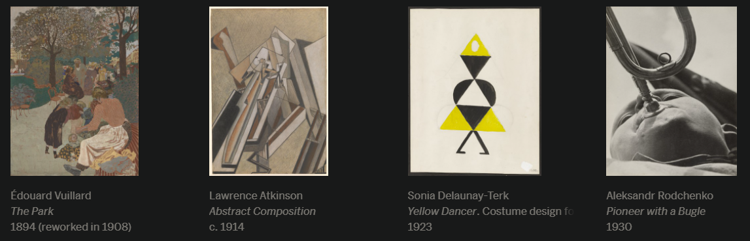

References

1. TATE, Avant-garde art term, Available at: <https://www.tate.org.uk/art/art-terms/a/avant-garde> (Last accessed 03/2021)
2. The Museum of Modern Art, Avant-garde, Available at: <https://www.moma.org/collection/terms/165> (Last accessed 03/2021)
3. Cambridge Dictionary, “the avant-garde, noun”, Available at: <https://dictionary.cambridge.org/dictionary/english/avant-garde> (Last accessed 03/2021)